Instance Type:

1. After Creating instance, we need to stop the instance, then only instance type works, click the check box and go to Actions --> Instance type --> Change instance type.

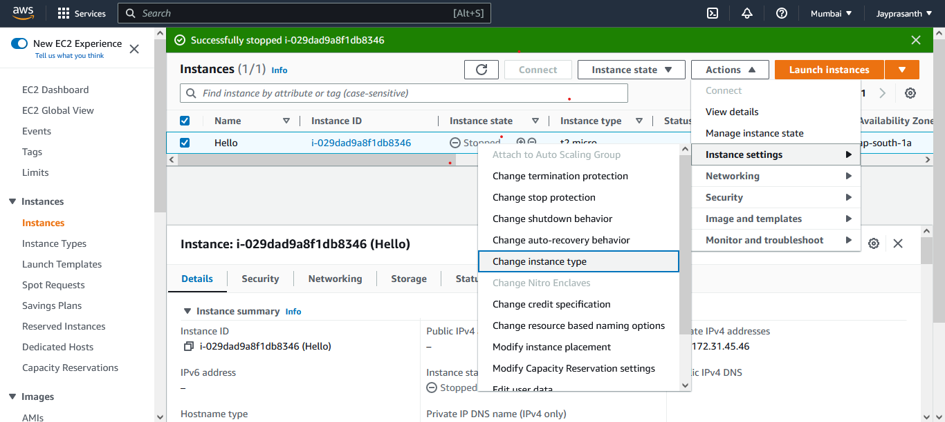

2.this shows the Instance type click the choose box and select the type

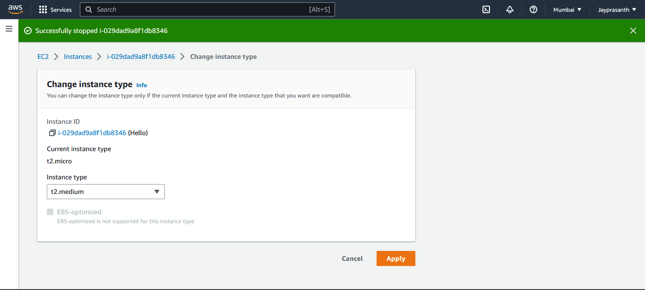

3.it successfully change to t2.micro to t2.medium.

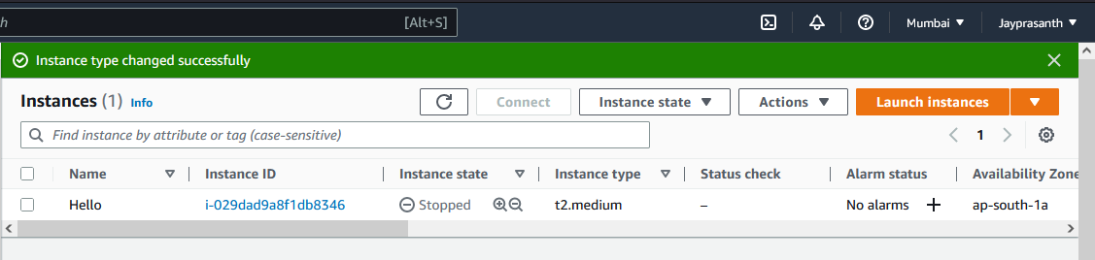

4. then it runs, after use we terminate the instance directly.

